C auris Screening in Healthcare Facilities

Obtaining consent prior to screening
All patients screened for C auris should agree in advance to the screening. If necessary, consent may be provided by a patient’s identified power of attorney (POA). Use the script that follows in Appendix I to educate patients or the POA about why you are conducting screening, how the swab is collected, and what a positive test would mean. A verbal consent is adequate unless your facility leadership requires a signed consent.

Screening for C auris
Testing for Candida auris is performed at the Washington State Department of Health (DOH) Public Health Laboratory (PHL). All materials, shipping, and testing are no cost. The DOH will send you sample collection kits prior to the planned date of screening along with all the other supplies needed for packaging and shipping.

Sample collection
Collecting the samples is simple. It is most conveniently performed when a patient is having regularly planned care, such as dressing, bathing, or checking vital signs.
- For C. auris, it involves swabbing the skin of both axillae (armpits) followed by both sides of the groin (where the leg meets the body) using a special a nylon-flocked swab (BD or Copan Eswab).

Obtaining results
Positive results will be communicated immediately to your infection preventionist by telephone. Positive and negative results are also communicated either by fax or electronically depending on how the requisition was submitted.

Collection and shipping instructions
The collection and shipping instructions should be followed precisely to ensure that specimens are collected and shipped correctly. See the instructions for C auris in Appendix II. Contact arln@doh.wa.gov and audrey.brezak@doh.wa.gov if you have any questions.

Next steps after screening
Public Health will work with your facility on appropriate next steps depending on the screening results.
- If one or more patient tests positive, more widespread screening at your facility will be recommended to determine if any has transmission occurred.

Appendix I: Script for obtaining verbal consent to be screened for C. auris
Hi, my name is [insert name] and I work for [insert organization]. I’m here to talk to you about testing that the [insert healthcare facility e.g., hospital or nursing home] is doing to check for certain germs.
We are looking for a germ that is difficult to treat and can spread easily in hospitals and nursing homes.
- One of these germs is called Candida auris and it is a type of yeast that can be resistant to many of the drugs used to treat it.
Some people can carry these germs on their skin or in their body fluids without any symptoms and they can spread the germ to others without knowing it.
The chance that you carry this germ is low, and fortunately, most people who carry it don’t get sick from it. There are a few reasons why it can be helpful to test patients for this germ. First, your doctors will be able to make better decisions for you about your medical care if they know whether you carry this germ. Second, [insert healthcare facility e.g., hospital or nursing home] and Public Health need to know who is carrying the germ so that they can help prevent it from spreading.
The test is not painful and there should be no side effects. If you agree to be tested, the process is simple.
- To test for the yeast, Candida auris, we would use a soft swab, like a Q-tip, to swab both sides of your armpit and your groin (the area where your leg meets your body).
The swabs will be sent to a lab to check for the germs, and the results are usually available within several days. If the results show you carry this germ, someone will contact you to discuss what to do next. The test results will be kept confidential to the extent allowed by law.
Agreeing to these swabs is voluntary. Do you have any questions? [pause for questions]. Is it OK if we collect the swabs?
Source: CDC, Example verbal consent for collection of swab to assess colonization with Candida auris, https://www.cdc.gov/fungal/diseases/candidiasis/pdf/C-auris-assent-for-screening-template.pdf

Appendix II: C. auris screening collection and submission instructions
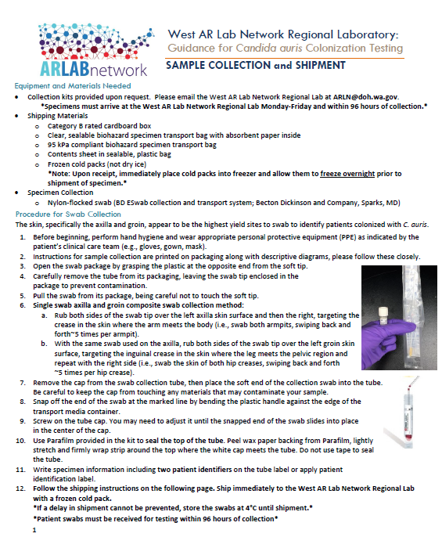
Please note, you should swab both sides of the axilla and both sides of the groin.

